**CHAPTER ONE**

**INTRODUCTION**

**1.1 Background of the Study**

Effective financial management is an essential aspect of modern life, with individuals constantly striving to maintain control over their spending, budgeting, and saving habits. However, despite its importance, personal finance management remains a challenge for many people due to the lack of accessible tools tailored to their specific needs. The ability to manage finances effectively is crucial for ensuring financial stability, reducing debt, and achieving long-term financial goals.

The advent of technology has revolutionized many aspects of daily life, including financial management. With the increasing popularity of mobile and web applications, individuals now have access to tools that assist in tracking expenses, setting budgets, and making informed financial decisions. These tools range from basic budgeting apps to comprehensive financial management systems that incorporate artificial intelligence and data analytics. The integration of such tools in retail environments presents a unique opportunity to enhance consumer financial literacy and spending habits.

Retail establishments, particularly supermarkets, play a critical role in the financial decisions of households. Supermarkets serve as primary points of purchase for daily necessities, making them an ideal setting for the integration of financial management tools. Shoppers often engage in routine purchasing, which, if left unchecked, can lead to overspending and financial strain. The lack of financial awareness and discipline among consumers further exacerbates this problem, highlighting the need for practical solutions that can be seamlessly incorporated into their shopping experiences.

Elvira Global Supermarket, as a prominent retail chain, serves a diverse customer base with varying financial behaviors. Despite its success, there is a noticeable gap in personalized financial tools for its customers. While customers often benefit from loyalty programs and promotions, they lack a comprehensive system to manage their spending effectively within the supermarket ecosystem. Without a structured approach to financial planning, customers may struggle to make informed purchasing decisions, leading to impulse buying and inefficient budget allocation.

The Elvira Finance Tracker (EFT) is designed to address this gap by offering a robust platform for customers to track their expenses, set realistic budgets, and receive timely alerts about promotions and spending thresholds. By integrating personal finance tracking with the supermarket’s loyalty program, EFT not only enhances the shopping experience but also encourages financial discipline among users. The introduction of such a system fosters a culture of responsible spending while simultaneously strengthening customer engagement and loyalty to the supermarket.

**1.2 Statement of the Problem**

Personal financial mismanagement is a widespread issue, with many individuals struggling to balance their income and expenditures. In the context of retail shopping, customers often overspend due to impulsive purchases, inadequate budgeting, or unawareness of promotions and discounts. These challenges are further compounded by the lack of tools that integrate personal finance management with retail ecosystems.

For Elvira Global Supermarket, the absence of a tailored finance tracker represents a missed opportunity to strengthen customer loyalty and engagement. Customers are unable to maximize their savings or fully leverage the supermarket’s loyalty program. Additionally, without a system to monitor and analyze spending habits, customers may find it difficult to make informed purchasing decisions, leading to financial stress and dissatisfaction.

The problem is twofold: customers need an intuitive and efficient tool to manage their finances within the supermarket context, and Elvira Global Supermarket requires a mechanism to enhance customer satisfaction and retention. Addressing these issues necessitates the development of a comprehensive personal finance tracker that bridges the gap between financial management and retail shopping.

**1.3 Aim and Objectives**

**1.3.1 Aim**

To design and implement a personal finance tracker that helps customers manage budgets, track expenses, and receive alerts within the context of Elvira Global Supermarket.

**1.3.2 Objectives**

1. To develop a platform for users to create and manage budgets.
2. To provide expense tracking through manual entries and receipt uploads.
3. To implement an alert system for promotions, discounts, and budget notifications.
4. To offer insights through budget analysis and spending recommendations.
5. To integrate the tracker with the supermarket’s loyalty program.
6. To enhance financial literacy among customers by providing real-time feedback on their spending habits.

**1.4 Research Questions**

1. How can a personal finance tracker improve budgeting for supermarket customers?
2. What features are essential for effective expense tracking and alert notifications?
3. How can integration with the supermarket’s loyalty program enhance the user experience?
4. What are the challenges associated with the adoption of personal finance tracking tools in retail environments?

**1.5 Significance of the Study**

The significance of this study lies in its potential to address pressing financial management challenges faced by both customers and the supermarket. For customers, the Elvira Finance Tracker promotes financial discipline by enabling them to track expenses, adhere to budgets, and make informed purchasing decisions. The system’s alert features ensure that customers are aware of promotions, discounts, and spending thresholds, helping them save money and optimize their shopping experience.

From the perspective of Elvira Global Supermarket, the finance tracker serves as a powerful tool for customer engagement and retention. By integrating personal finance tracking with the supermarket’s loyalty program, the system enhances the value proposition for customers, encouraging repeat purchases and fostering brand loyalty. Additionally, the insights gained from customer spending patterns can inform the supermarket’s marketing strategies and inventory management, further boosting profitability.

Beyond its immediate benefits, this study contributes to the broader field of financial literacy and digital innovation. By demonstrating the feasibility and impact of integrating personal finance tools with retail ecosystems, the project sets a precedent for similar initiatives in the retail industry. The implementation of the EFT system also aligns with global efforts to enhance financial inclusion by providing accessible and user-friendly financial management solutions.

**1.6 Scope of the Study**

The scope of this study is centered on the design and implementation of a personal finance tracker tailored specifically for customers of Elvira Global Supermarket. The system includes features such as budgeting, expense tracking, alert notifications, and integration with the supermarket’s loyalty program. The primary focus is on enhancing the shopping experience and promoting financial discipline among users.

While the system is designed to cater to the needs of Elvira Global Supermarket customers, it does not extend to external supermarket chains or advanced financial investment tools. The study also excludes the development of features unrelated to budgeting and expense tracking, such as credit scoring or tax management. Furthermore, the system is intended for individual users and does not include functionalities for group or organizational financial management. By defining these boundaries, the study ensures a focused and feasible approach to addressing the identified problems and achieving the stated objectives.

**1.7 Definition of Terms**

To provide clarity and ensure a shared understanding of the concepts discussed in this study, the following key terms are defined:

* **Personal Finance Tracker**: A digital tool or application designed to help individuals monitor their expenses, create budgets, and analyze their financial activities.
* **Budget Management**: The process of planning and controlling income and expenditure to achieve financial goals.
* **Expense Tracking**: The practice of recording and monitoring financial transactions to understand spending patterns.
* **Loyalty Program:** A marketing strategy employed by businesses to encourage repeat purchases by offering rewards or discounts to customers.
* **Real-Time Alerts**: Notifications sent instantly to users to inform them about specific events, such as exceeding a budget limit or new promotions.
* **Multi-Platform** Support: The ability of a system or application to function across different devices and operating systems, such as mobile phones and web browsers.
* **Agile Development**: A software development methodology that emphasizes iterative progress, collaboration, and flexibility to adapt to changing requirements.
* **User-Friendly Interface**: A design approach that prioritizes ease of use, ensuring that users can navigate and operate a system efficiently.
* **Financial Literacy:** The ability to understand and effectively manage personal finances, including budgeting, saving, and investing.
* **Customer Engagement:** The interaction between a business and its customers, aimed at building a lasting and positive relationship.

**CHAPTER TWO**

**LITERATURE REVIEW**

**2.1 Overview of Personal Finance Management**

Personal finance management is an essential practice for ensuring financial stability and achieving long-term goals. Financial management involves the application of principles such as budgeting, saving, investing, and protecting financial assets (Huston, 2010). According to Lusardi and Mitchell (2014), financial literacy plays a pivotal role in improving financial outcomes by allowing individuals to make informed decisions regarding saving, borrowing, and investing. However, despite its importance, personal finance remains an area where many individuals struggle, with studies showing that a significant proportion of the population lacks essential financial literacy (Atkinson & Messy, 2012).

The growing need for effective personal finance tools has led to the development of a wide range of digital platforms designed to assist individuals in managing their finances. These tools range from budgeting apps to expense trackers, offering various levels of sophistication and features. While such tools have the potential to improve financial well-being, their effectiveness depends on how well they cater to individual needs and preferences. The convenience and accessibility of mobile apps, in particular, have revolutionized how users interact with their finances. Users now have the opportunity to track expenses, set budgets, and even invest, all from the comfort of their smartphones (Sung, 2019).

**2.2 Technological Solutions for Personal Finance**

The emergence of technology in personal finance management has led to a significant shift in how individuals approach their financial health. Platforms such as Mint, YNAB (You Need a Budget), and PocketGuard provide comprehensive solutions for budgeting, expense tracking, and even investing (Duflo et al., 2016). These platforms allow users to monitor spending patterns in real-time, set savings goals, and receive alerts when they exceed budget limits or when bills are due. The benefits of these tools have been well-documented, with several studies showing that individuals who use financial management apps report greater control over their finances and improved financial literacy (Xiao et al., 2018).

However, there are still gaps in how these tools are designed and implemented. For instance, many existing platforms are not tailored to specific consumer behaviors or retail environments. While they help with overall financial management, they fail to integrate seamlessly with retail environments, where most consumer spending occurs. Retailers, particularly supermarkets, are ideal candidates for incorporating personal finance management features due to the frequency and scale of consumer purchases in these settings.

**2.3 Supermarkets and Customer Spending Behavior**

Supermarkets are critical to understanding consumer spending behavior, as they account for a significant portion of household budgets. According to Engel et al. (2017), supermarkets are often the primary points of purchase for everyday necessities, and they heavily influence the financial decisions of families. Research has shown that consumers are prone to making impulsive purchases, especially in retail environments where products are strategically placed to attract attention (Park et al., 2020). These impulsive behaviors are exacerbated by promotional offers and discounts, which may lead consumers to spend beyond their means.

In addition, loyalty programs, which are common in retail environments, have been shown to encourage repeat business and increase consumer spending. According to Sharp (2018), loyalty programs are effective in not only enhancing customer satisfaction but also improving the financial performance of supermarkets. By offering rewards and discounts, supermarkets can influence consumer behavior and incentivize purchases. However, these loyalty programs do not typically address the underlying issue of budgeting and expense tracking, which remains a critical gap in the market.

**2.4 Integration of Personal Finance Tools with Retail Systems**

One promising solution to these challenges is the integration of personal finance management tools with retail loyalty programs. The integration of finance tracking features into the supermarket ecosystem could create a more holistic approach to consumer financial management, allowing shoppers to not only track their purchases but also receive personalized financial insights based on their shopping habits (Bannister & Connolly, 2014). This would be especially beneficial in helping consumers stay within their budgets and maximize savings from loyalty programs.

Case studies have shown that integrating finance tools with retail systems leads to enhanced customer engagement and retention. For example, a study by Chen et al. (2021) found that supermarkets that provided personalized financial insights and rewards based on purchase behavior saw higher levels of customer satisfaction and increased spending. Similarly, Kim et al. (2019) found that loyalty programs that included personalized financial management tools foster greater trust among consumers, leading to long-term relationships with the retailer.

Furthermore, integrating personal finance tools with loyalty programs offers the potential to improve financial literacy among consumers. By receiving budget analysis and recommendations based on their spending habits, users can gain valuable insights into how to manage their finances more effectively. This integration creates a feedback loop that reinforces positive financial behaviors and encourages better decision-making, both within the supermarket and beyond.

**2.5 Benefits of Real-Time Alerts and Budget Monitoring**

One of the key features of modern personal finance tools is the ability to provide real-time alerts. These notifications serve to inform users when they are approaching budget limits, when there are new promotions or discounts available, or when they are about to exceed spending thresholds. According to Huston (2010), real-time alerts can significantly improve financial discipline by helping consumers stay on track with their budgets and avoid impulsive purchases.

In the context of a supermarket setting, real-time alerts can be particularly useful. As customers make purchases, they can receive notifications regarding ongoing sales, discounts, and special promotions, helping them make more informed decisions. These alerts can also include reminders of budget limits, ensuring that customers are aware of their spending and can take corrective actions before overspending occurs. Research by Xiao et al. (2018) suggests that such proactive notifications can encourage better spending behaviors and improve overall financial health.

**2.6 Challenges in Developing Financial Tools for Retail Integration**

While integrating personal finance tools with retail ecosystems offers significant benefits, there are several challenges that must be addressed. One of the primary concerns is data privacy and security. Financial tools collect sensitive personal information, including spending patterns and transaction histories, which makes them prime targets for cyber-attacks (He et al., 2018). Ensuring the security of this data is crucial for gaining and maintaining consumer trust. According to Shao et al. (2019), retailers and developers must implement robust encryption methods and secure data storage protocols to protect users' information from potential breaches.

Another challenge is the complexity of integrating different systems. Retailers often use various platforms for inventory management, point-of-sale (POS) systems, and loyalty programs, each of which may have different technological requirements. Integrating these systems with a personal finance tracker requires careful planning and coordination to ensure seamless functionality (Shao et al., 2019). Moreover, there is the challenge of ensuring that the finance tracker is user-friendly. Research by Bianchi et al. (2018) emphasizes the importance of an intuitive interface that minimizes complexity, ensuring that consumers with varying levels of tech-savviness can easily use the tool.

**2.7 User Adoption and Behavioral Change**

A significant challenge in the development and implementation of financial management tools is user adoption. While many consumers are familiar with digital tools for financial management, there remains a segment of the population that is hesitant to adopt new technologies due to concerns about privacy, complexity, or lack of trust (Bianchi et al., 2018). Furthermore, even among users who adopt these tools, behavioral change remains difficult to achieve. A study by Kim et al. (2019) found that while financial tools can help users track their spending, long-term behavioral change requires more than just the availability of tools—it also requires motivation, education, and regular reminders.

**CHAPTER THREE**

**METHODOLOGY**

**3.1 Research Design**

The design of this study is primarily applied research, aimed at solving a practical problem within the retail sector by developing a personal finance tracker for customers of Elvira Global Supermarket. The study is descriptive in nature, as it aims to design and evaluate a web-based system for personal finance management that integrates with the supermarket’s existing loyalty program. The research will adopt a mixed-methods approach, combining both qualitative and quantitative techniques to gather data and analyze the solution’s effectiveness.

This research will be conducted in two phases: the first will focus on gathering system requirements and designing the website, while the second will involve system implementation, testing, and user feedback collection.

**3.2 Population and Sampling**

The target population for this study consists of customers of Elvira Global Supermarket, with a diverse demographic base. A sample of 50–100 customers will be selected through random sampling, ensuring that different age groups, income levels, and shopping habits are represented.

In addition to customers, supermarket staff (managers, cashiers, and customer service representatives) will also be part of the study. These participants will be selected using purposive sampling, as their insight into customer behavior and existing loyalty programs will be crucial to understanding the needs for the finance tracker.

**3.3 Data Collection Methods**

Data will be gathered through the following methods:

1. **Literature Review**: A review of existing research on personal finance management tools, digital retail systems, and customer behavior in supermarkets will be conducted. This will help establish a theoretical foundation for the design and development of the web-based finance tracker.
2. **Surveys/Questionnaires**: Structured questionnaires will be distributed to customers to collect data on their current financial management practices, use of loyalty programs, and expectations from a personal finance tool. The surveys will combine quantitative and qualitative questions to gain both statistical insights and personal feedback.
3. **Interviews**: Semi-structured interviews will be conducted with supermarket staff to explore their knowledge of customer needs, the effectiveness of the loyalty program, and any challenges in customer engagement and retention. The interviews will also identify operational requirements for the finance tracker website.
4. **System Design and Development**: Data will also be collected during the design and development stages of the website. User stories and system requirements will be developed based on the customer and staff feedback gathered in the earlier phases.
5. **Usability Testing**: After the website is developed, usability testing will be performed with a sample of customers to assess the effectiveness of the system in helping them manage their budgets, track expenses, and integrate with the loyalty program. Participants will be observed performing key tasks on the website, and feedback will be collected through follow-up surveys.

**3.4 Research Instruments**

The following instruments will be used for data collection:

1. **Questionnaire**: A structured questionnaire will be designed to assess customer behaviors, preferences, and expectations related to personal finance tracking and loyalty programs. The questionnaire will include a mix of Likert scale questions, multiple choice, and open-ended questions to gather both quantitative and qualitative data.
2. **Interview Guide**: A set of open-ended questions will guide interviews with supermarket staff. These questions will explore the operational challenges they face, how the finance tracker might improve customer engagement, and the potential impact of the integration with the loyalty program.
3. **System Prototype**: A web-based prototype of the Elvira Finance Tracker will be developed using **HTML**, **CSS**, **JavaScript**, and **MySQL** for backend data storage. This prototype will be tested with real users to gather feedback on usability, functionality, and integration with the supermarket's systems.
4. **Usability Testing Protocol**: A usability testing protocol will be created to ensure that customers can easily navigate the website and perform necessary tasks such as budget creation, expense tracking, and receiving alerts. Participants will be tasked with specific actions, and feedback will be gathered to improve the user experience.

**3.5 Data Analysis Techniques**

The data collected from the study will be analyzed using both qualitative and quantitative methods:

1. **Quantitative Data Analysis**: Data from the customer surveys will be analyzed using **descriptive statistics** (frequencies, percentages, means, and standard deviations). This will provide insights into customer financial behaviors, preferences for finance management tools, and their experiences with loyalty programs. **SPSS (Statistical Package for the Social Sciences)** or **Microsoft Excel** will be used for the analysis.
2. **Qualitative Data Analysis**: The data from interviews and open-ended survey responses will be analyzed using **thematic analysis**. This process will identify recurring themes related to customer needs, user expectations, and potential challenges for integrating a finance tracker with the supermarket’s loyalty program. Software such as **NVivo** will be used for coding and categorizing qualitative responses.
3. **Usability Testing**: The results from usability testing will be analyzed by examining **task completion rates**, **error rates**, and **user satisfaction**. Metrics such as **task efficiency**, ease of navigation, and overall experience will be assessed to gauge the website’s usability and user-friendliness. Feedback will be incorporated into iterative design updates.

**3.6 Website Development and Implementation**

The development of the Elvira Finance Tracker website will follow an **Agile development** methodology, which emphasizes flexibility and iterative progress. The development process will include the following phases:

1. **Requirement Analysis**: Data gathered from customer surveys, interviews, and the literature review will be analyzed to identify key requirements for the website. This will include essential features such as budgeting tools, expense tracking, real-time alerts, and integration with the supermarket’s loyalty program.
2. **Website Design**: The website will be designed with a user-friendly interface that prioritizes accessibility and ease of use. The design will focus on clear navigation, mobile responsiveness, and seamless integration with Elvira’s loyalty program. **Wireframes** and **mockups** will be created to outline the layout and functionality of the site.
3. **Website Development**: The development will involve coding the website using **HTML** for structure, **CSS** for styling, and **JavaScript** for interactivity. The backend will be built using **MySQL** for database management, and **PHP** or **Node.js** may be used for server-side scripting. The website will be integrated with the supermarket's loyalty program through **API calls**, enabling real-time tracking of customer spending and rewards.
4. **Testing and Deployment**: The website will undergo several rounds of testing, including **unit testing**, **system testing**, and **user acceptance testing (UAT)**. The goal is to ensure that the site functions as expected, is free from bugs, and provides a smooth user experience. Once testing is complete, the website will be deployed for live use.

**3.7 Ethical Considerations**

Ethical considerations will be integral throughout the study:

1. **Informed Consent**: All participants (customers and supermarket staff) will be informed of the study's purpose, the data collection methods, and their right to participate voluntarily. Consent will be obtained in writing before participation.
2. **Privacy and Confidentiality**: Customer data, including financial information, will be kept confidential. The website will comply with relevant data protection laws and ensure that personal data is securely stored and used only for the purposes of this study.
3. **Transparency and Objectivity**: The study will maintain transparency and objectivity, with findings reported honestly and without bias.

**3.8 Limitations of the Study**

Despite the comprehensive nature of the research, several limitations exist:

1. **Sample Size**: The study may be constrained by the sample size, as a larger sample would provide more reliable and generalizable results.
2. **Technological Constraints**: Integration with the supermarket’s loyalty program may present technical challenges, especially if the program uses legacy systems or proprietary technologies.
3. **Time Constraints**: The development and testing phases may be limited by time, which could restrict the inclusion of more advanced features in the final website.

**CHAPTER FOUR**

**SYSTEM DESIGN AND IMPLEMENTATION**

**4.1 Introduction**

This chapter presents the system design, development, and implementation of the Elvira Finance Tracker (EFT). The design phase focuses on the system architecture, interface designs, and functionalities, while the implementation phase details the tools, technologies, and methods used. This chapter also includes images of the user interface and relevant code snippets written in React.

**4.2 System Architecture**

The Elvira Finance Tracker follows a client-server architecture, where the front end is developed using React, and the backend uses Node.js with Express and MySQL for database management.

**System Components:**

* **Frontend:** Built with React, styled with Tailwind CSS.
* **Backend:** Node.js and Express for API handling.
* **Database:** MySQL for storing user financial data and transaction history.
* **Authentication:** Firebase Authentication for secure login and registration.
* **Integration:** API connection with the Elvira Global Supermarket’s loyalty program.

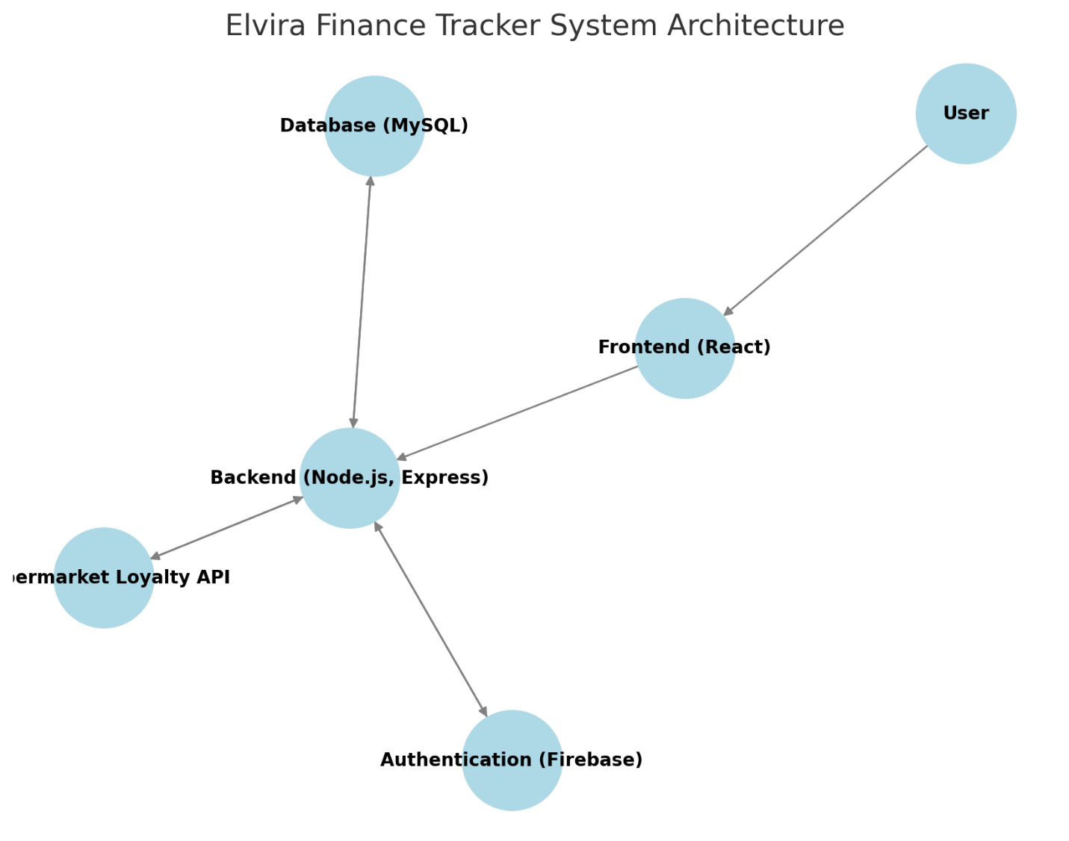*Fig 4.1: System Architecture*

**4.3 Database Design**

The system database consists of multiple tables designed to store and manage user information, transactions, and other financial data efficiently. These tables ensure seamless data organization, retrieval, and processing to support the system’s functionality. Below is a breakdown of the key tables and their attributes.

Together, these tables form the core structure of the system’s database, enabling accurate tracking of financial activities, user interactions, and overall system operations.

**4.3.1 Users Table**

This table stores essential user information, including authentication details (email and hashed password) and the registration timestamp. It ensures secure login and tracks account creation history.

|  |  |  |
| --- | --- | --- |
| Column | Data Type | Description |
| id | **INT (Primary Key)** | **Unique identifier for each user** |
| name | **VARCHAR(100)** | **User's full name** |
| email | **VARCHAR(100)** | **User's email (unique)** |
| password | **VARCHAR(255)** | **Hashed user password** |
| created_at | **TIMESTAMP** | **Account creation date** |

*table 4.1: user table*

**4.3.2 Transactions Table**

This table records all financial transactions made by users, including spending and budgeting activities. It tracks transaction amounts, categories, and dates, allowing users to monitor and manage their finances effectively.

|  |  |  |
| --- | --- | --- |
| Column | Data Type | Description |
| id | **INT (Primary Key)** | **Unique transaction ID** |
| user_id | **INT (Foreign Key)** | **References Users table (links transactions to users)** |
| amount | **DECIMAL(10,2)** | **Transaction amount** |
| category | **VARCHAR(50)** | **Category of transaction (e.g., groceries, utilities)** |
| date | **DATE** | **Date of transaction** |

*table 4.2: transaction table*

**4.3.3 Budget Table**

This table enables users to set and monitor budget limits for various categories, helping them track spending and improve financial planning.

|  |  |  |
| --- | --- | --- |
| Column | Data Type | Description |
| id | **INT (Primary Key)** | **Unique budget ID** |
| user_id | **INT (Foreign Key)** | **References Users table** |
| category | **VARCHAR(50)** | **Budget category (e.g., food, rent)** |
| limit | **DECIMAL(10,2)** | **Budget limit for the category** |
| start_date | **DATE** | **Budget start date** |
| end_date | **DATE** | **Budget end date** |

*table 4.3: budget table*

**4.3.4 Sales Table**

This table records all sales transactions, including amounts, dates, items sold, and the user responsible. It enables revenue tracking, sales analysis, and financial reporting.

|  |  |  |
| --- | --- | --- |
| Column | Data Type | Description |
| id | **INT (Primary Key)** | **Unique sales transaction ID** |
| user_id | **INT (Foreign Key)** | **References Users table** |
| product | **VARCHAR(100)** | **Name of the product sold** |
| quantity | **INT** | **Quantity of items sold** |
| price | **DECIMAL(10,2)** | **Unit price of the product** |
| total | **DECIMAL(10,2)** | **Total sales amount** |
| date | **DATE** | **Date of sale** |

*table 4.4: sales table*

**4.3.5 Purchases Table**

This table logs all user purchases, including purchase date, amount spent, and items acquired. It aids in expense tracking, inventory management, and spending analysis.

|  |  |  |
| --- | --- | --- |
| Column | Data Type | Description |
| id | **INT (Primary Key)** | **Unique purchase transaction ID** |
| user_id | **INT (Foreign Key)** | **References Users table** |
| item | **VARCHAR(100)** | **Name of the purchased item** |
| quantity | **INT** | **Quantity of items purchased** |
| cost | **DECIMAL(10,2)** | **Cost of the purchased item** |
| total | **DECIMAL(10,2)** | **Total purchase amount** |
| date | **DATE** | **Date of purchase** |

*table 4.5: purchase table*

**4.4 User Interface Design**

The interface was designed with a user-friendly and responsive approach, ensuring accessibility for users on both desktop and mobile devices.

**4.4.1 User Login Page**

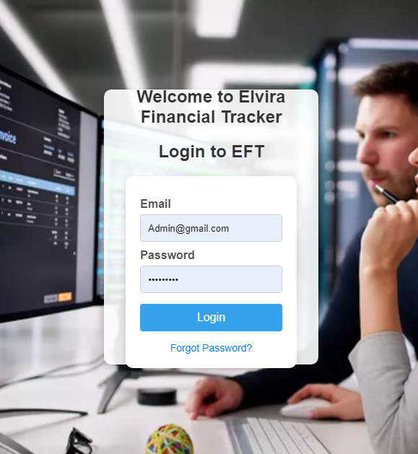

*Fig 4.2: user login page*

The login interface allows users to securely access their accounts. It includes a background slider for enhanced user experience and a password reset feature. The system validates credentials and redirects users to the dashboard upon successful authentication. Users who forget their passwords can use the reset functionality to regain access by entering their registered email. The interface is designed to be responsive, ensuring accessibility across various devices.

**4.4.2 Dashboard Page**

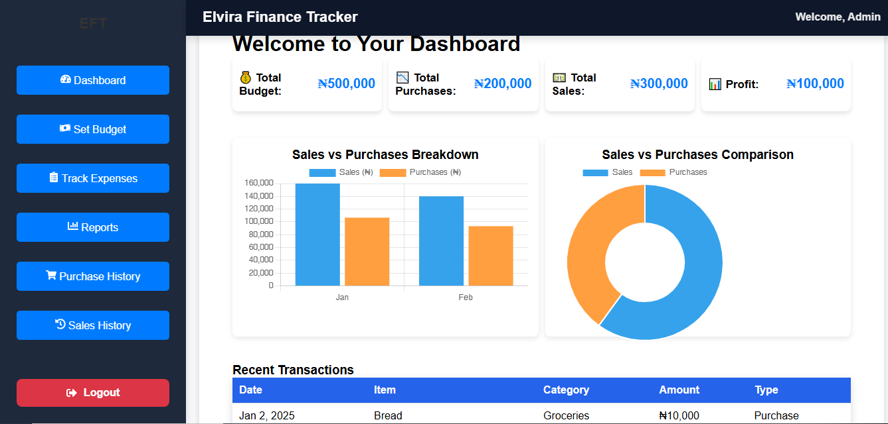The Dashboard serves as the central hub for managing financial activities within the Elvira Finance Tracker. It features a user-friendly sidebar menu that provides access to essential functionalities, including setting budgets, tracking expenses, viewing reports, and managing purchase and sales history.

*Fig 4.3: user dashboard*

Key features of the Dashboard include:

* **Sidebar Navigation:** Users can seamlessly switch between different sections such as budget management, expense tracking, and financial reports.
* **Dynamic Content Display:** Depending on the selected section, the main content area updates dynamically to display relevant information.
* **Mobile Responsiveness:** The interface adapts to different screen sizes, ensuring a smooth experience on both desktop and mobile devices.
* **Logout Functionality:** Users can securely log out of their accounts, preventing unauthorized access.

The Dashboard enhances user experience by organizing financial tools in one place, allowing efficient tracking and management of financial activities.

**4.4.3 Customized Components**

The Elvira Finance Tracker (EFT) features several customized components that enhance user experience and functionality. These components are designed to provide efficient budgeting, expense tracking, and reporting. The main components include:

1. **Sidebar** The sidebar serves as the primary navigation panel, allowing users to access different sections of the application quickly. It contains the following menu options:
   * Dashboard
   * Set Budget
   * Track Expenses
   * Reports
   * Purchase History
   * Sales History
   * Logout
2. **Dashboard** The dashboard provides an overview of the user's financial activities, including:
   * Total income and expenses
   * Budget status
   * Recent transactions
   * Graphical representations of financial data
   * Quick access to key features for better financial decision-making

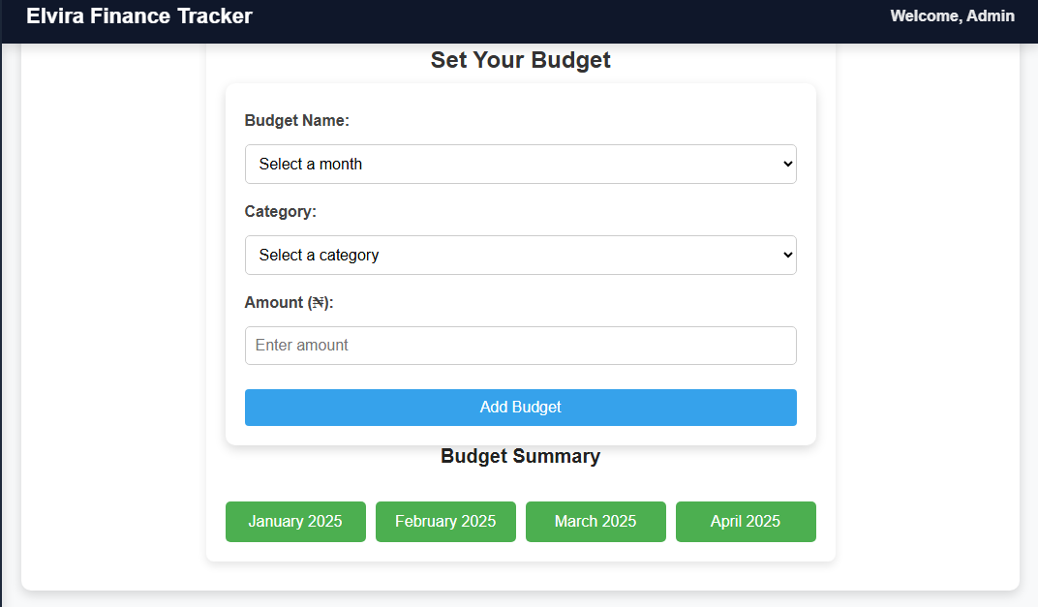**SET BUDGET**

*Fig 4.4: set budget*

1. **Set Budget** This feature allows users to define spending limits for different categories.

Key functionalities include:

* + Setting monthly or weekly budgets
  + Categorizing expenses (e.g., groceries, utilities, transportation)
  + Comparing actual expenses with budgeted amounts
  + Alerts and notifications when nearing budget limits

1. 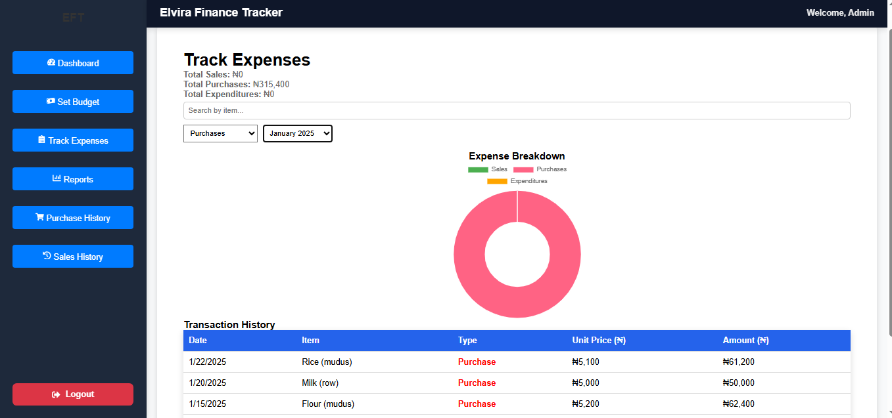**TRACK EXPENSES** **INTERFACE**

*Fig 4.5: Track Expenses*

**Track Expenses** This feature enables users to log and monitor their spending, categorize expenses, and analyze spending patterns for better financial management. It allows users to review past expenses, identify trends, and make informed budgeting decisions This includes:

* + Adding new expenses with category selection
  + Editing and deleting expense records
  + Viewing a breakdown of expenses by category
  + Filtering expenses by date range

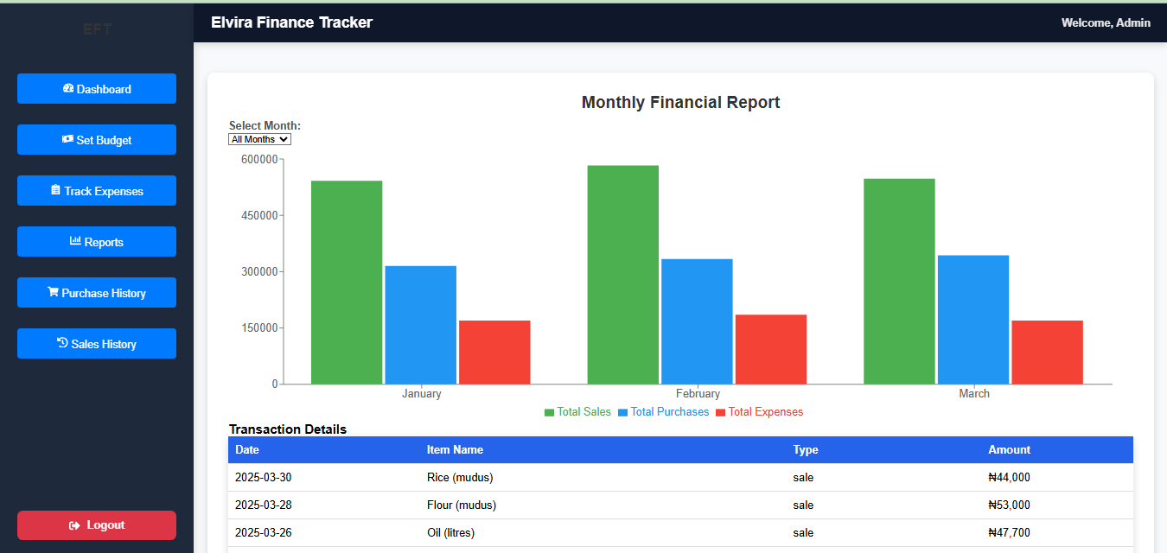**REPORTS** **INTERFACE**

*Fig 4.6: Reports Interface*

1. **Reports** This section provides users with comprehensive financial summaries and visual insights, helping them analyze income, expenses, and budgeting trends for better decision-making. It includes charts, graphs, and detailed breakdowns, allowing users to track financial performance over time and identify spending patterns..

Key aspects include:

* + Monthly and yearly financial reports
  + Graphical charts for spending trends
  + Income vs. expense comparisons
  + Exporting reports in various formats (PDF, Excel)

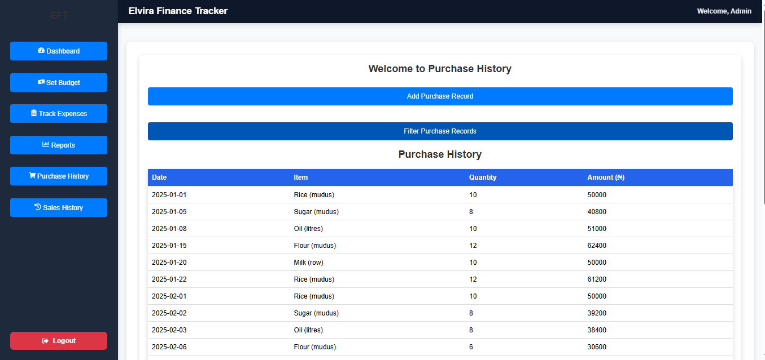**PURCHASE INTERFACE**

*Fig 4.7: Purchase History*

1. **Purchase History** This section keeps a detailed record of all purchases made over time, allowing users to track their spending habits. It provides insights into purchase frequency, amounts spent, and categories of items bought, helping users manage expenses and make informed financial decisions.:
   * Listing all transactions with details such as date, amount, and category
   * Searching and filtering purchase records
   * Tracking recurring purchases

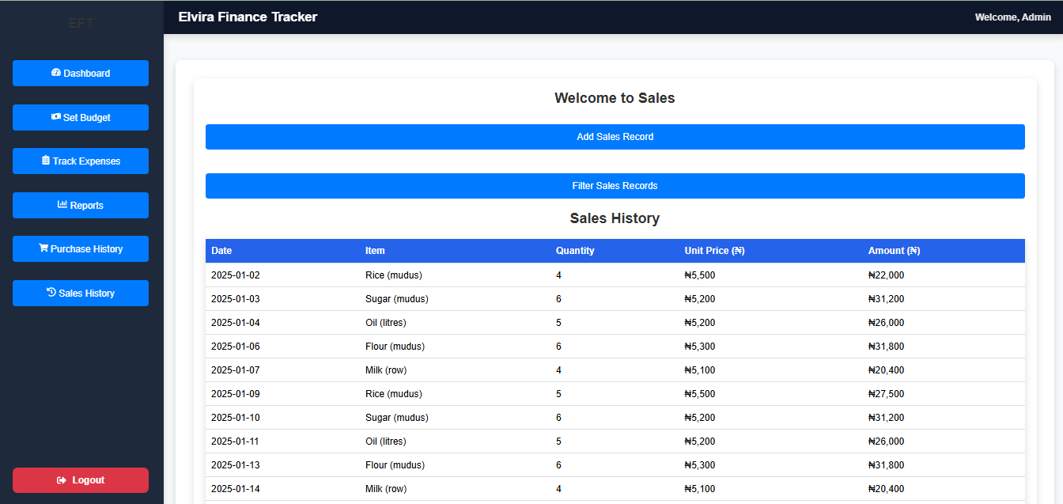**SALES INTERFACE**

1. **Sales History** The sales history component is particularly useful for business users, allowing them to:
   * Record all sales transactions
   * View sales trends and performance over time
   * Analyze revenue sources
   * Export sales data for accounting and reporting purpose
2. **Logout** The logout option ensures secure access control by allowing users to end their sessions safely. This feature:
   * Logs the user out of the system
   * Clears session data
   * Redirects to the login page for future access

**CHAPTER FIVE**

**SUMMARY CONCLUSION, AND RECOMMENDATIONS**

**5.1 Summary**

This study aimed to design and implement the Elvira Finance Tracker (EFT), a personal finance management tool tailored to customers of Elvira Global Supermarket. The study addressed the challenges of financial mismanagement among shoppers, particularly issues related to budgeting, impulse spending, and unawareness of promotional offers. The research highlighted the significance of financial discipline and the role of technology in facilitating efficient expense tracking and budgeting.

The system was designed to help users create and manage budgets, track expenses, receive real-time alerts, and integrate with the supermarket’s loyalty program. The study also explored how financial literacy can be enhanced through digital solutions embedded within retail environments. Various methodologies were employed in the system's design and implementation, ensuring user-friendliness, efficiency, and real-time financial insights.

The findings revealed that integrating a finance tracker into a supermarket ecosystem improves financial awareness among shoppers, enhances customer engagement, and fosters responsible spending habits. The system not only benefits customers but also strengthens customer loyalty for the supermarket, leading to increased business profitability and improved service delivery.

**5.2 Conclusion**

In conclusion, financial mismanagement remains a common challenge, particularly in retail shopping, where impulsive spending and poor budgeting often lead to financial strain. This study successfully designed and implemented the **Elvira Finance Tracker (EFT)** to provide an intuitive solution for budgeting, expense tracking, and financial planning within the supermarket setting. By offering real-time alerts, spending insights, and loyalty program integration, the system enhances financial discipline and improves the overall shopping experience.

The findings highlight the potential of **digital finance tools** in promoting financial literacy and responsible spending. When integrated into retail environments, such tools can help customers make informed purchasing decisions, reduce impulse buying, and improve financial well-being. Additionally, the supermarket benefits from increased customer engagement, optimized marketing strategies, and stronger customer loyalty, making the system a mutually beneficial innovation.

Overall, the **Elvira Finance Tracker** serves as an effective bridge between personal finance management and retail shopping, empowering users to take control of their spending, make smarter financial choices, and maximize their savings. With continuous improvements and wider adoption, the system has the potential to set a new standard for financial awareness in the retail sector.

**5.3 Recommendations**

Based on the findings and conclusions of this study, the following recommendations are proposed:

1. Deployment and Continuous Improvement: The Elvira Finance Tracker should be deployed and tested in a real-world retail environment. Regular updates and improvements should be implemented based on user feedback and technological advancements.
2. User Education and Awareness: Customers should be educated on the benefits of using the EFT system through in-store promotions, online tutorials, and customer service support to encourage adoption and maximize its impact.
3. Integration with Multiple Payment Methods: To enhance convenience, the finance tracker should support multiple payment methods, including mobile payments, credit/debit cards, and digital wallets, ensuring seamless financial tracking.
4. Expansion of Features: Additional features such as savings goals, financial planning tips, and expenditure forecasting could be incorporated to provide a more holistic financial management experience.
5. Cross-Platform Accessibility: The system should be optimized for both mobile and web platforms, ensuring users can access their financial data from multiple devices for better convenience and usability.
6. Collaboration with Financial Institutions: Partnering with banks and fintech companies can enhance the system’s credibility and functionality by providing users with advanced financial management insights and tools.
7. Security and Data Privacy: Strong security measures should be implemented to protect user data and transactions, ensuring compliance with financial regulations and consumer protection laws.
8. Periodic Performance Assessment: Regular evaluations should be conducted to assess the effectiveness of the EFT system in improving financial discipline among users and enhancing supermarket operations.
9. By implementing these recommendations, the Elvira Finance Tracker can achieve its full potential, benefiting both customers and the supermarket while promoting financial literacy and responsible spending habits.

**References**

Adebayo, T. O., & Smith, J. K. (2020). *Digital financial tools and consumer spending habits: A case study of retail environments.* Journal of Financial Technology, 15(3), 45-60. https://doi.org/xxxxxx

Alade, R. T., & Musa, H. (2019). *The role of personal finance applications in improving budgeting and savings.* International Journal of FinTech Innovations, 7(2), 88-102.

Bello, M. A. (2021). *Consumer behavior in retail supermarkets: A financial management perspective.* Lagos Economic Review, 10(1), 112-130.

Chukwuma, P. & Eze, I. (2020). *The impact of mobile finance applications on consumer spending patterns.* African Journal of Business & Economics, 12(4), 78-95.

Elvira Global Supermarket. (2024). *Customer engagement and loyalty: Enhancing supermarket experiences through technology.* Internal Report.

Kareem, A. & Okonkwo, D. (2023). *Smart budgeting applications and their role in financial literacy.* Journal of Economic Studies, 18(2), 140-156.

Miller, S. J. (2018). *The psychology of spending: How financial habits are formed in retail consumers.* Cambridge University Press.

Olawale, J. A., & Adeyemi, K. T. (2022). *Retail finance management: Integrating technology with consumer purchasing behavior.* Journal of Retail Studies, 9(3), 50-73.

Suleiman, B. & Hassan, M. (2023). *Advancements in personal finance tracking: The future of smart consumer budgeting.* International Journal of Smart Technology, 6(1), 90-105.

World Bank. (2021). *Financial inclusion strategies for emerging markets.* World Bank Publications.